EDA-SQL

EDA is the first step of data analysis project.

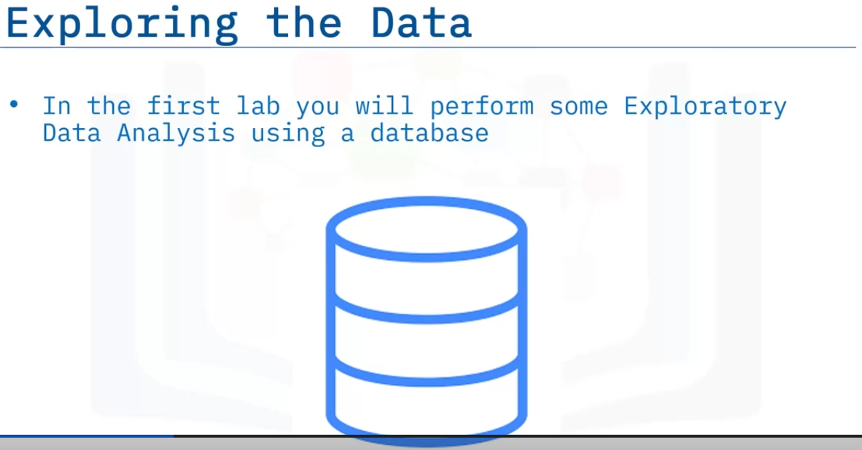

Some features can be used to determine the outcome. So we perform feature engineering to find useful features.

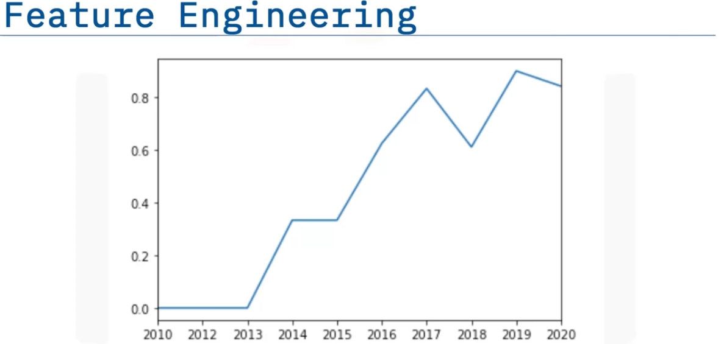

We can see that the success rate has increased from 2013. This can be considered for the model using the launch number.

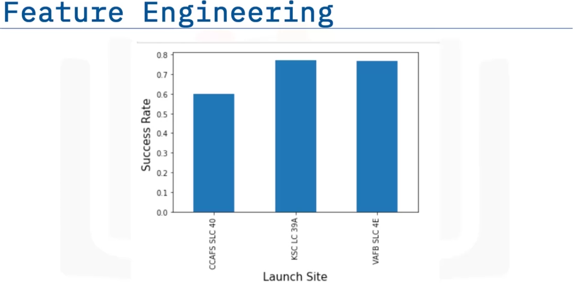

We can see that different launch sites have different success rates. We can use this to determine if the landing happens successfully.

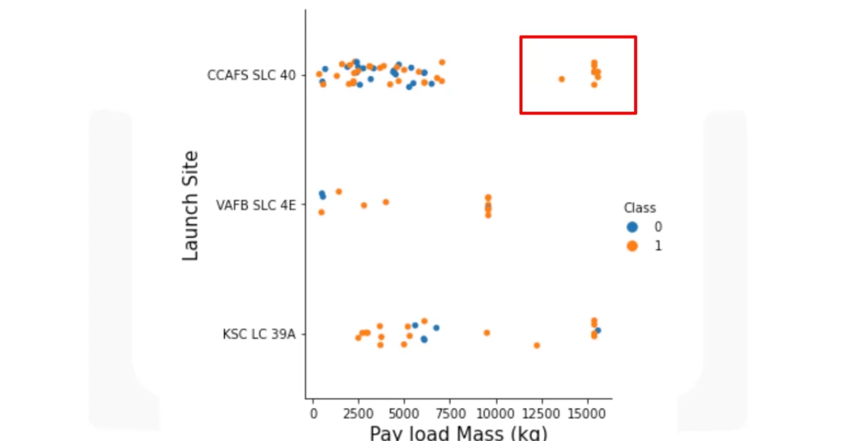

We can include another attribute like payload Mass and we can se that the success rate CCAFS LC-40 has 60% success rate but if the payload is over 10000kg then the success rate is 100%. So we can use multiple features for the prediction.

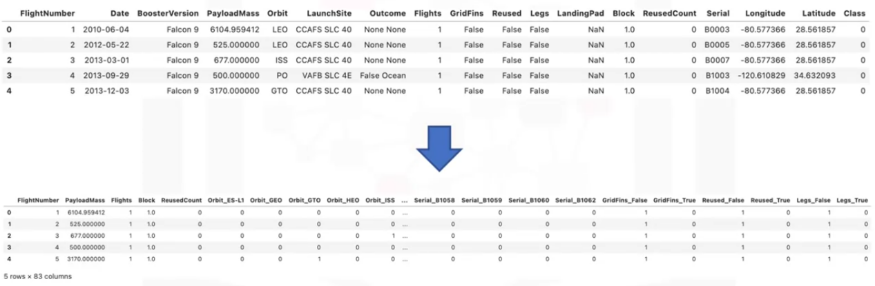

In the lab which attributes are correlated to the outcome. To perform the predictions we we need to convert the categorical variables to numerical variables using one hot encoding.